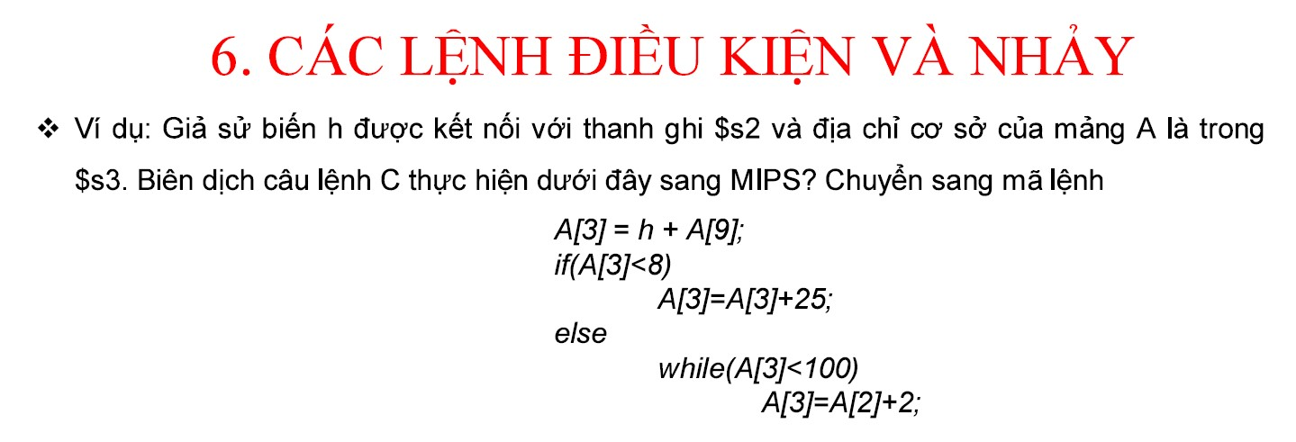

*A[3] = A[3]+2*

*Bài tập chuẩn bị cho thi giữa kỳ và cuối kỳ:*

1. Chuyển đoạn code trên từ C sang assembly
2. Sau đó, biểu diễn lệnh Assembly sang binary code
3. Gửi đáp án bằng file word hoặc pdf tới email thầy: **thien.luongvan@phenikaa-uni.edu.vn**
4. lw $t0,36($s3)

add $t0,$t0,$s3

slti $t1,$t0,8

beq $t1,$zero,Loop

addi $t0,$t0,25

j Exit

Loop: slti $t1,$t0,100

beq $t1,$zero,Exit

addi $t0,$t0,2

j Loop

Exit: sw $t0,12($s3)

2.

|  |  |  |  |  |  |  |
| --- | --- | --- | --- | --- | --- | --- |
|  | op | Rs | Rt | Rd | shamt | funct |
| lw $t0,36($s3) | 100011 | 10011 | 01000 | 0000 0000 0010 0100 | | |
| add $t0,$t0,$s3 | 000000 | 01000 | 10011 | 01000 | 00000 | 100000 |
| slti $t1,$t0,8 | 001010 | 01000 | 01001 | 0000 0000 0000 1000 | | |
| beq $t1,$zero,Loop | 000100 | 01001 | 00000 |  | | |
| addi $t0,$t0,25 | 001000 | 01000 | 01000 | 0000 0000 0001 1001 | | |
| j Exit | 000010 |  | | | | |
| Loop:  slti $t1,$t0,100 | 001010 | 01000 | 01001 | 0000 0000 0110 0100 | | |
| beq $t1,0,Exit | 000100 | 01001 | 00000 |  | | |
| addi $t0,$t0,2 | 001000 | 01000 | 01000 | 0000 0000 0000 0010 | | |
| j Loop | 000010 |  | | | | |
| Exit sw $t0,12($s3) | 101011 | 10011 | 01000 | 0000 0000 0000 1100 | | |

.data

A: .word 1,2,3,-5,1,-2,3,4,6,5

.text

main:

lui $s3,0x1001#$s3=0x00000000->$s3=0x10010000

li $s2,4 #bien h

lw $t0,36($s3) #$t0 = A[9] = 5

add $t0,$t0,$s2 #$t0 = h + A[9]

slti $t1,$t0,8 #$t1 = 1 if $t0<8, else $t1=0

beq $t1,$zero,Loop # jump to while loop

addi $t0,$t0,25 #$t0 = $t0+25

j Exit

Loop:

slti $t1,$t0,100 #$t1=1 if $t0<100, else $t1=0

beq $t1,$zero,Exit

addi $t0,$t0,2 #$t0 = $t0+2

j Loop

Exit: sw $t0,12($s3) #A[3] = $t0